Experiment No : 02

Aim : Study any 1 Semantic Web Open Source Tools like Apache TinkerPop, RDFLib, Apache Jena, Protégé, Sesame

# Introduction to RDFLib

RDFLib is a powerful open-source library in Python used to work with RDF (Resource Description Framework) data. It provides tools for parsing, querying, storing, and manipulating RDF graphs, making it an essential tool for Semantic Web applications. RDF is a fundamental technology used to describe relationships between resources in a structured manner, enabling linked data and knowledge representation across the web. RDFLib simplifies the handling of this structured data by providing a flexible and user-friendly API for developers to work with RDF models efficiently.

By using RDFLib, developers can create RDF graphs, serialize them into various formats, and perform queries using SPARQL to extract meaningful information. This makes it a vital component in applications involving semantic search, data integration, and intelligent data retrieval. Whether working with simple structured data or complex ontologies, RDFLib provides the necessary functionalities to enhance data interoperability and improve information retrieval processes.

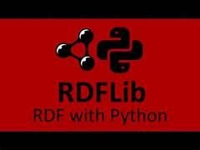

# Features of RDFLib

* Supports multiple serialization formats like Turtle, RDF/XML, JSON-LD, and N-Triples, allowing flexibility in data representation and storage.
* Provides SPARQL support for querying RDF data, enabling efficient retrieval and manipulation of data stored in RDF graphs.
* Allows easy manipulation of RDF graphs in Python, providing an intuitive API for adding, removing, and updating triples.
* Integrates with various RDF databases (triple stores) for scalable data management, making it suitable for applications requiring persistent data storage.
* Enables inference and reasoning using RDFS and OWL ontologies, allowing the derivation of new knowledge based on existing facts.
* Includes support for namespaces, making it easier to manage and use RDF vocabularies effectively.
* Provides methods to merge multiple RDF graphs, facilitating data integration from different sources.
* Efficiently handles blank nodes and literals, ensuring proper data representation and querying capabilities.

# Installation of RDFLib

To install RDFLib in Python, use the following command:



RDFLib is lightweight and can be installed within seconds. It does not require complex dependencies, making it easy to integrate into existing Python projects. Additionally, RDFLib is compatible with major Python versions, ensuring widespread usability across different development environments.

For users needing extended functionality, RDFLib can be combined with additional Python libraries such as SPARQLWrapper for advanced SPARQL querying or NetworkX for visualizing RDF graphs. By leveraging these integrations, developers can enhance RDF data processing and analysis capabilities within their applications.

# Working with RDF Graphs using RDFLib

* 1. Creating an RDF Graph

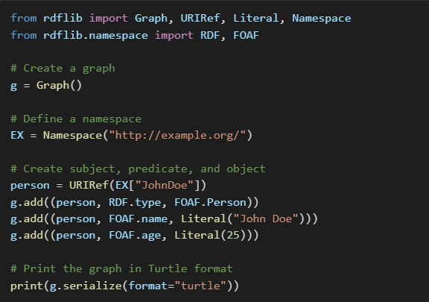

The above code demonstrates how to create an RDF graph using RDFLib, where an individual named "John Doe" is represented as an RDF resource with properties such as type (Person), name, and age. By defining a namespace, we ensure that URIs are structured in a standard format, making the data more interoperable.

* 1. Querying RDF Data using SPARQL

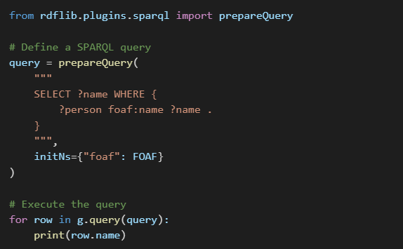

SPARQL is the standard query language for RDF data, allowing users to extract specific information from RDF graphs. The above query retrieves the name of individuals stored in the RDF graph, showcasing how RDFLib supports structured data retrieval efficiently.

1. Use Cases of RDFLib
2. Knowledge Graphs: RDFLib helps store and query semantic relationships in knowledge graphs, enhancing structured data representation and retrieval.
3. Linked Data: Used for integrating and querying linked data from different sources, ensuring data consistency across applications.
4. Ontology Management: RDFLib can be used with OWL ontologies for reasoning and inference, allowing automated knowledge discovery.
5. Metadata Management: Helps structure and retrieve metadata for digital libraries, improving information organization and accessibility.
6. Healthcare and Life Sciences: Used for representing medical terminologies and linking healthcare data for better analysis and decision-making.
7. E-Government and Smart Cities: Assists in managing open government data, enabling interoperability among different governmental agencies.
8. Advantages of RDFLib

* Easy to use for Python developers, providing a simple interface for RDF data manipulation.
* Supports multiple serialization formats, making it compatible with various data exchange standards.
* Allows flexible RDF data manipulation through an intuitive API, reducing development time.
* Compatible with Semantic Web standards, ensuring interoperability with other RDF tools and frameworks.
* Provides built-in SPARQL support for querying RDF data efficiently.
* Can be extended with additional modules for advanced reasoning and inference.
* Lightweight and requires minimal setup, making it ideal for both small-scale and large- scale applications.
* Enables the creation of structured and linked data models, improving data organization and retrieval.

1. Limitations of RDFLib

* Not suitable for very large datasets due to memory limitations, requiring integration with external RDF stores for scalability.
* Lacks built-in persistent storage (requires integration with RDF stores) to handle long- term data management efficiently.
* Performance can be slow for complex SPARQL queries on large graphs, necessitating optimizations for efficient querying.
* Limited support for advanced reasoning mechanisms compared to dedicated inference engines.
* Does not provide out-of-the-box visualization tools for RDF graphs, requiring integration with external libraries for data visualization.

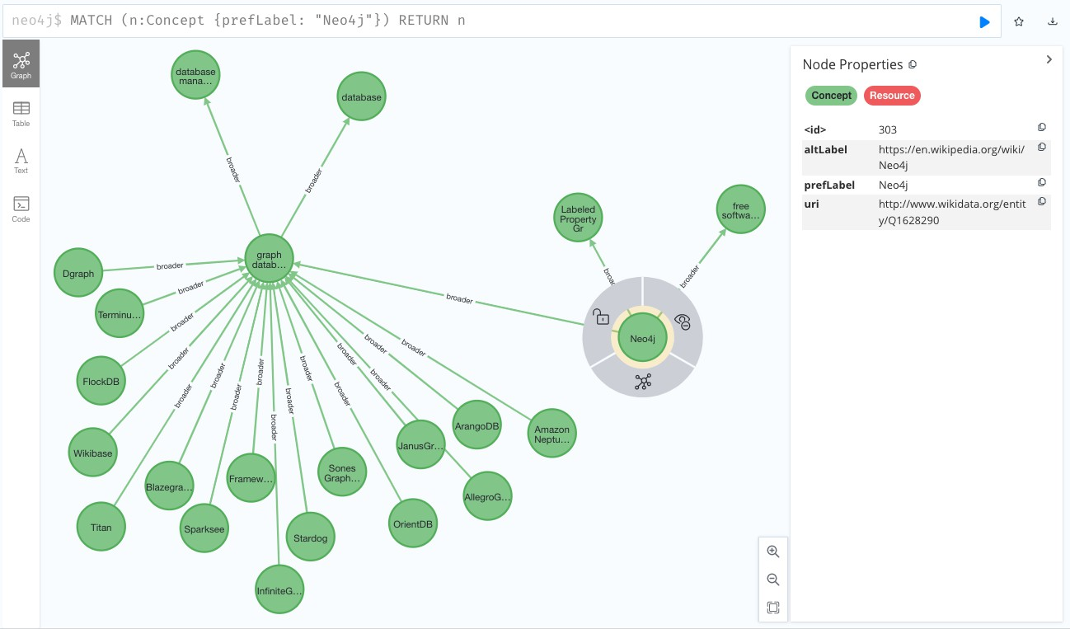

1. Conclusion

RDFLib is a beginner-friendly and powerful tool for working with RDF data in Python. It provides a simple interface for storing, querying, and manipulating RDF graphs, making it an essential tool for Semantic Web applications. With its flexibility and ease of use, RDFLib is widely adopted in academia and industry for knowledge representation and linked data applications.

By leveraging RDFLib, developers can build intelligent data-driven applications that facilitate better data integration, interoperability, and retrieval. Despite its limitations, its ease of use and extensive feature set make it a valuable tool for handling RDF data efficiently. As Semantic Web technologies continue to evolve, RDFLib remains a fundamental tool for working with structured data and fostering better knowledge management across various domains.